**PROJECT DESCRIPTION**

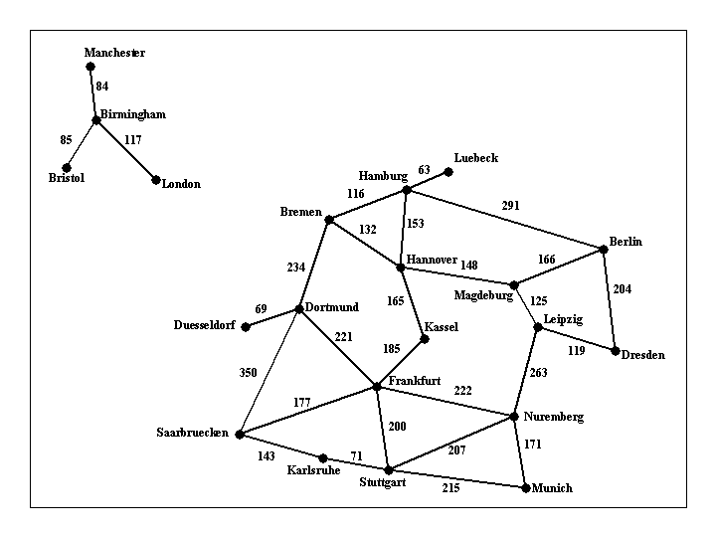

A search algorithm that can find a route between any two cities. The program will will take exactly commandline arguments as follows:  
  
***find_route input_filename origin_city destination_city*** ***heuristic_filename***  
  
An example command line is:  
  
find_route input1.txt Bremen Kassel (For doing Uninformed search)  
or  
find_route input1.txt Bremen Kassel h_kassel.txt (For doing Informed search)  
  
If heuristic is not provided then program does uninformed search. Argument input_filename is the name of a text file such as [input1.txt](http://crystal.uta.edu/~gopikrishnav/classes/2020/summer/4308_5360/assmts/assmt1_files/input1.txt), that describes road connections between cities in some part of the world.

For example, the road system described by file input1.txt can be visualized in Figure 1 shown above. You can assume that the input file is formatted in the same way as [input1.txt](http://crystal.uta.edu/~gopikrishnav/classes/2020/summer/4308_5360/assmts/assmt1_files/input1.txt): each line contains three items. The last line contains the items "END OF INPUT", and that is how the program can detect that it has reached the end of the file. The other lines of the file contain, in this order, a source city, a destination city, and the length in kilometers of the road connecting directly those two cities. Each city name will be a single word (for example, we will use New_York instead of New York), consisting of upper and lowercase letters and possibly underscores.  
  
The program will compute a route between the origin city and the destination city, and will print out both the length of the route and the list of all cities that lie on that route. It will also display the number of nodes expanded and nodes generated. For example,  
  
find_route input1.txt Bremen Kassel  
  
should have the following output:  
  
nodes expanded: 12  
nodes generated: 20  
distance: 297.0 km  
route:  
Bremen to Hannover, 132.0 km  
Hannover to Kassel, 165.0 km  
  
and  
  
find_route input1.txt London Kassel  
  
should have the following output:  
  
nodes expanded: 7  
nodes generated: 7  
distance: infinity  
route:  
none